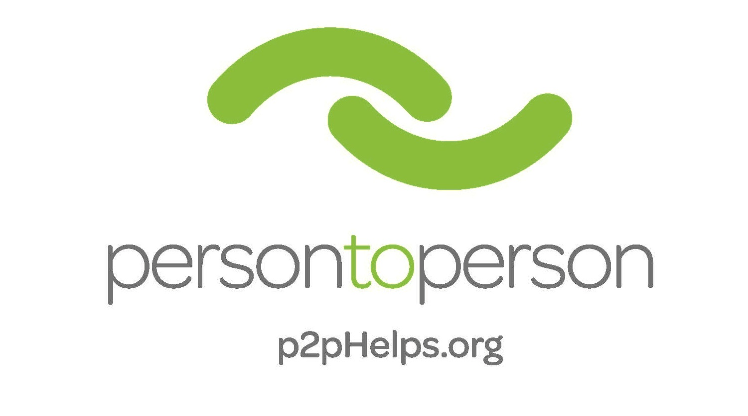
Want to Know More About Serving on P2P’s Board of Directors?

Service on the Board of Directors of Person-to-Person provides the right person with the opportunity to influence the direction of this growing agency, build relationships with a diverse group of community leaders, utilize your skills and make a meaningful impact on the lives of thousands of Fairfield County residents who seek our assistance.

Person-to-Person’s Mission Statement: P2P is a community-supported agency that provides individuals and families with assistance for basic needs to overcome daily challenges and access to resources to improve their lives.

Person-to-Person’s Vision Statement: Communities of educated, financially stable, and hunger-free homes for all.

Person-to-Person’s Values:
Community: We honor the contributions of all.
Volunteers: Service is the heart of the organization.
Integrity: We are honest, fair, responsible, and ethical.
Respect: We treat everyone who walks through the doors with dignity.
Quality: We are committed to what we do, and we do it well.

Background and History

Person-to-Person (P2P) is a community-supported agency that creates equitable access to economic stability for financially struggling individuals to move towards stability. Founded out of the pain following the assassination of Dr. Martin Luther King Jr. in 1968 by a group of parishioners at St. Luke’s Episcopal Church in Darien, the organization began in two closets with volunteers distributing used clothing and canned food to those in need. Over the years, services have grown to advance the agency’s overarching vision of creating communities of financially-stable, hunger-free homes, with educational opportunities for all.

In 1996, OPUS for Person-to-Person, a mission based volunteer organization, was formed to raise awareness and to fundraise for P2P. To date, OPUS has raised over $6.5 million to help P2P clients. In 2015, P2P merged with Christian Community Action, more than doubling our food distribution and expanding services to the Norwalk community. In 2018, P2P launched P2P on Wheels, a mobile pantry that brings nutritious food to residents of Stamford’s most in-need neighborhoods. The launch of P2P on Wheels increased P2P’s food distribution by an additional 50%.

P2P’s operating budget for fiscal year 2022 is approximately $16M with $5.8M in cash contributions and $10M in in-kind donations. P2P relies on over 3,000 volunteers to provide services throughout the year and they contribute 84,000 hours of their time. This allows over 90% of donations to go directly to our client programs.

P2P’s website is www.p2pHelps.org. Follow us on Instagram @persontopersonct, and Facebook at Person-to-Person.

Programs and Services

This year alone, P2P’s work will touch the lives of nearly 28,000 individuals – including 11,000 children – in Stamford, Norwalk, Darien, New Canaan, Westport, Wilton, and Weston. The agency’s core programs are as follows:

- Three food pantries and Door2Door Home Delivery: P2P’s three self-select food pantries, located in Norwalk, Darien and Stamford (P2P on Wheels), provide access to healthy food to 21,000 individuals. Clients may visit monthly to receive a full week’s complement of food including dairy, protein and fresh fruits and vegetables. Those who are unable to visit the pantries may have their groceries delivered to their door using our Door2Door program. In 2021, we launched a summer meals program for students. During the economic downturn precipitated by the coronavirus pandemic, P2P’s food distribution jumped by an additional 70%. In the period between 2010 and 2021, P2P’s food distribution increased from 134,500 meals to 2,000,000 meals.
- Clothing Center and Holiday Programs: Clients may “shop” monthly for new and gently used clothing, outerwear and shoes that are donated by the community to P2P’s Clothing Center in Darien. We host an annual “Keep Norwalk Warm” coat giveaway of over 2,000 winter coats. Residency within P2P’s catchment area is not required to participate in the Clothing Center program.
- Baby Basics and Holiday Programs: OPUS for Person to Person raises funds for and distributes brand new car seats and layettes to parents of newborns referred through Stamford Hospital. Additional programs include back-to-school backpacks and supplies, diapers, brand new coats and new toys, games and stuffed animals through the annual Holiday Toy Store. The Dove program is a partnership between P2P, local churches and partner agencies to provide Christmas dinners to hundreds of local families.
- Casework support: P2P’s eight bi-lingual caseworkers provide support, information and referrals to help clients manage situational crises. Caseworkers also determine eligibility for and administer the Emergency Financial Assistance program. The program helps prevent problems from becoming worse and helps tie together community resources and our partner agencies.
- Emergency Financial Assistance: The Emergency Financial Assistance Program assists clients through their situational crises by providing funds for rent, security deposits, utilities, workforce training, child enrichment and unexpected expenses. Funds are paid to third parties on behalf of the clients.
- Campership Program: Working with school guidance counselors and through an on-site registration program, P2P’s campership program sends children from low-income families to local day camps during the summer, allowing parents to continue to work knowing their children are safe and cared for. During the summer of 2019, Person-to-Person funded camperships for approximately 400 children, primarily from the Stamford Public Schools, ensuring they spent their summer days in a fun and engaging environment with access to academic enrichment.
- Scholarship Program: The P2P Scholarship Program’s overarching goal is to help students change the trajectory of their lives by achieving a college education, so the next generation moves out of poverty. Eligible high school graduates receive scholarships ranging from $500 to $5,000 to help bridge the gap between the money needed to attend college and the total amount a student has available. For the 2021-22 school year, P2P awarded 104 scholarships. P2P’s graduation rates of >80% are far ahead of comparable national rates for students in general, at 60% and those from low-income backgrounds, which hover at 16%.

The Mentoring 4 Success Program awards a select group of incoming freshmen a scholarship of $5,000 a year and matches each student with a trained, dedicated mentor who will support them through all four years of college. The Mentoring 4 Success program has been a great success, with high-performing students and graduation rates approaching 90%.

Service on the Board of Directors

The Person-to-Person Board meets 6 - 7 times annually (September, November, January/February, April, May and June). The meetings usually are held at P2P Darien on Wednesday evenings from 6 – 8 pm. During the pandemic, meetings are held virtually.

Expectations:
The Board of Directors of Person-to-Person directs the affairs of the agency in accordance with its mission, including hiring and overseeing the Chief Executive Officer; evaluating long-term strategy; approving budgets and major capital expenditures; ensuring the integrity of financial statements and internal controls; ensuring compliance with applicable laws, regulations and ethical standards; overseeing the agency’s management of risk; assisting in obtaining financial and other resources and determining governance practices.

To this end, Board members are expected to be prepared for and attend all Board meetings and serve on two Board committees, participate in development, fundraising and friend-raising functions, volunteer at P2P periodically, and to introduce colleagues and friends to P2P. Board members are expected to make an annual financial contribution according to their means and make P2P one of their top three charitable recipients.

Board Governance:
Board members annually sign Conflict of Interest Statement and Disclosure Forms. P2P maintains a Whistleblower Policy, Document Retention Policy, Advocacy Policy, and Diversity, Equity and Inclusion Statement. P2P maintains Directors’ & Officers’ insurance in the amount of $5M.

Board Committees, Task Forces and Liaisons:
Audit Committee: The Audit Committee oversees the selection and performance of the agency’s annual outside audit.

Development Committee: The Development Committee works with the CEO and philanthropy team to oversee the organization's overall fundraising efforts and marketing/communications efforts, including event fundraising.

Executive Committee: The Executive Committee is composed of the following officers of P2P – President, 1st Vice President, Treasurer and Secretary. The CEO/Executive Director is an ex-officio member of the Executive Committee (without voting rights.) Per the bylaws, the Executive Committee serves at the pleasure of the Board of Directors and may exercise all authority and powers of the Board of Directors as shall be provided in a resolution adopted by a majority of the Board, or as may thereafter be expanded or restricted by subsequent resolutions, so far as may be permitted by law. The Executive Committee sets the agenda for all board meetings.

Finance & Risk Committee: This committee works with the finance team to set and review budgets and report to the board on the financial health and risks to the organization.

Governance Committee: The Governance Committee is responsible for the general affairs of the Board and the board nomination, orientation and self-assessment functions.

Endowment Committee: The Endowment Committee is responsible for overseeing the management of the Janet Evans Endowment Fund.

Programs Committee: The Programs Committee supports the staff execution of P2P’s programs: Critical Needs Assistance, Campership, and Scholarship.

Vestry Liaison: The Vestry Liaison acts as a conduit of information between the Rector of St. Luke’s Parish and Person-to-Person.

OPUS Liaison: The OPUS Liaison acts as a conduit of information between the OPUS Board and the P2P Board of Directors.

Diversity, Equity and Inclusion Committee: The Diversity, Equity and Inclusion (DEI) Committee champions and promotes the agency’s efforts to incorporate a DEI lens into all aspects of the agency’s work, including is program execution, staff management and Board recruitment and governance, in accordance with the adopted DEI Action Plan.

